**Installing Visual Studio and SQL Server Integration Services (SSIS)**

1. Download Visual Studio 2019 from <https://visualstudio.microsoft.com/downloads/>
2. Run the downloaded .exe file
3. A scree as shown below will be presented

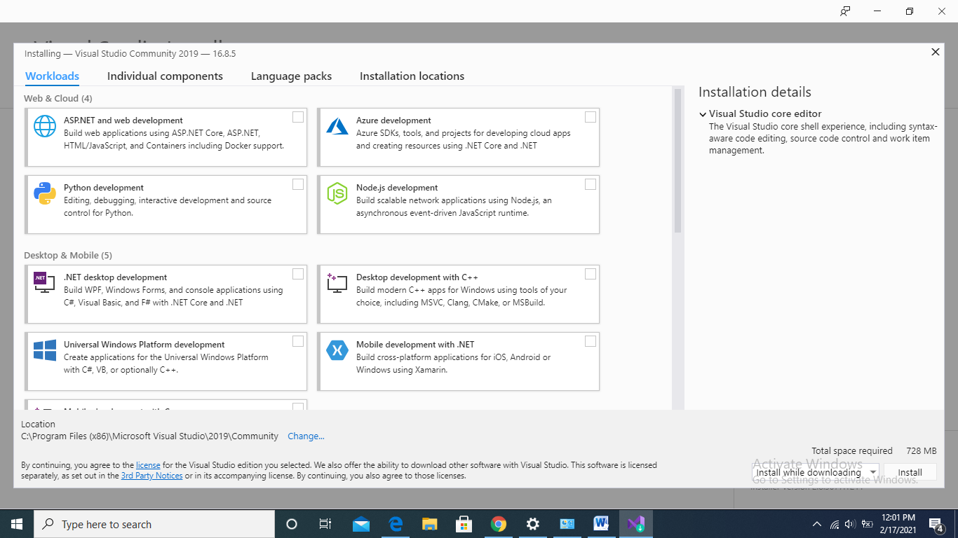

1. Select the “individual components” tab from the screen
2. Next, select the data tools check box from the screen as shown below. All relevant check boxes will be selected automatically.

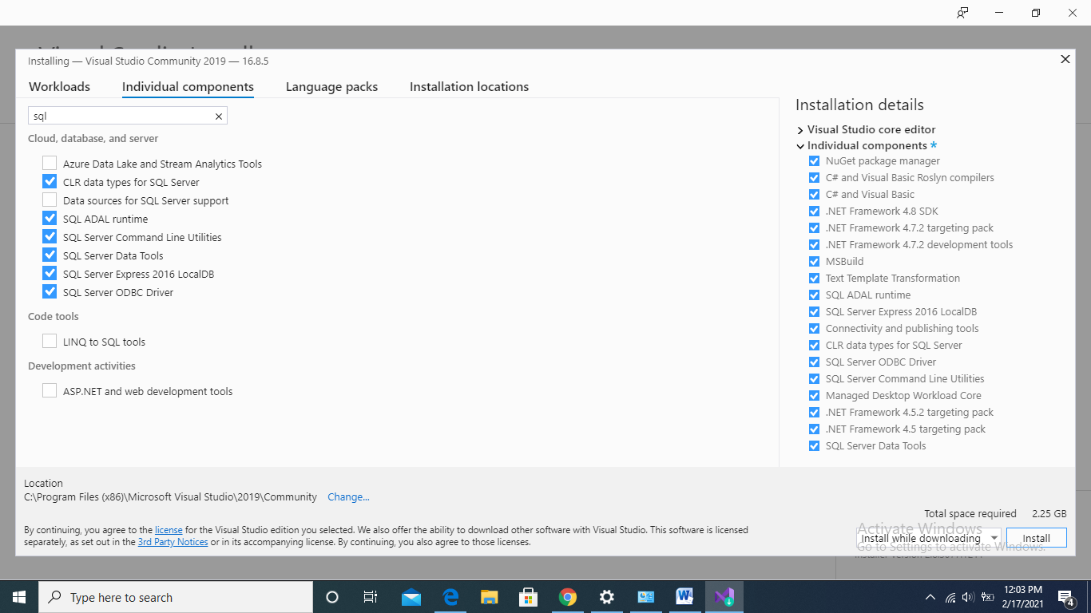

1. Next, click “Install” button. If the dialog asks for “Add Workloads” then accept its installation as well
2. The visual studio will start installing as shown in the following figure. Please wait for the installation to complete

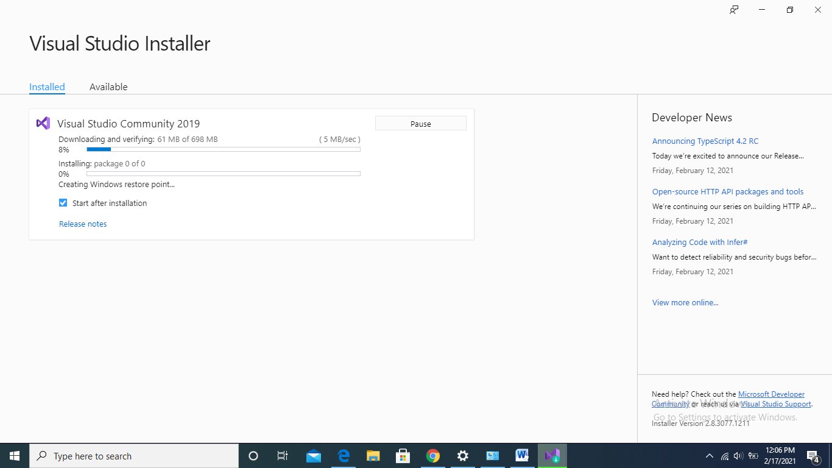

1. After installation launch the visual studio. Congratulations you have installed the instance of visual studio 2019.
2. For installation of SSIS, click the “continue without code” option after launching visual studio
3. Next, click on the “Extensions” menu and select “Manage Extensions” sub menu. You will see a screen as shown below.

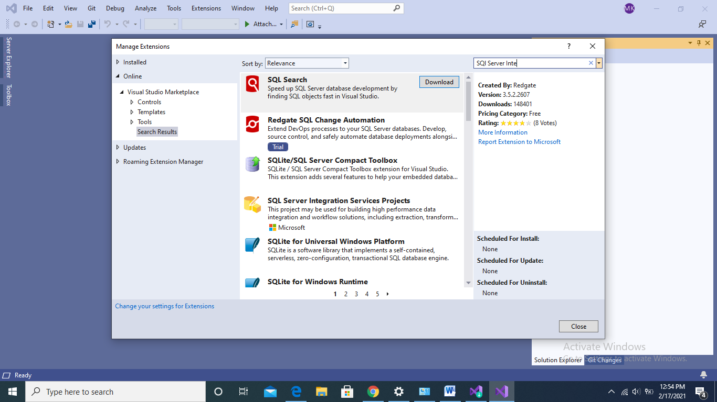

1. 11. Next, in the “search” option of the screen type “SQL Server Integration”. You will see “SQL Server Integration Services Projects” in the “Downloads” section of the previous screen
2. Next, Click the “SQL Server Integration Services Projects” and click “Download”. Download the file in your desired folder on local disk
3. Next, run the downloaded setup file and follow the instructions with default options selected. You might need to restart your system to run the SSIS
4. Once, the SSIS is installed on your system, launch the Visual Studio and select “Create a new Project”
5. Next, select the “Integration Services Project” from the type of projects
6. Name the project as “First Project” and save the project in the desired folder on your local disk. Next, click “Create”. You will be able to see the following screen of the SSIS

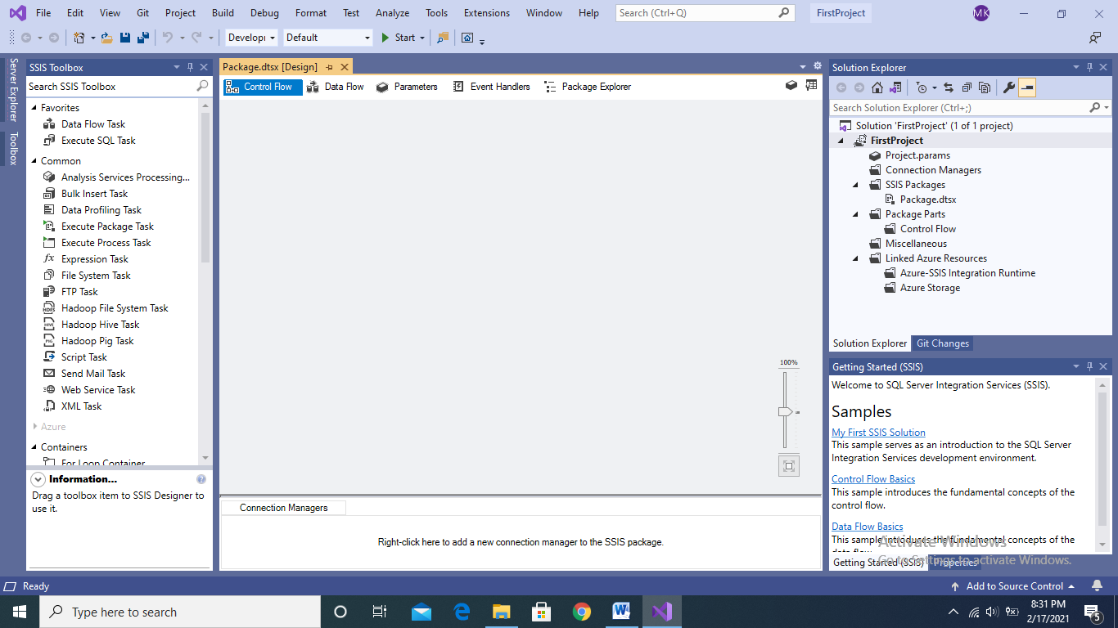

1. Congratulations you have completed the installation and instantiation of the SSIS